Enneagram and the Pandemic – What is Your Gut Telling You?

Laura Clapp, an NL Moore & Associates assessment team member became a Certified Enneagram Coach in February 2019. She shares her expertise on how your Enneagram type is dealing with the Covid-19 pandemic. This is part 1 of 3.

When I came across a personality tool called the Enneagram, I was skeptical. I have often felt boxed in by these types of assessments. As I dug a little deeper, I discovered the uniqueness of this tool, and it has changed my life. Most tools focus on behavior, while the Enneagram focuses on the motivation behind the behavior. To me, it was like looking beyond the symptoms to the root issue of how we all behave. It answered my questions about why different people make different choices in life. We all look through different lenses, and those lenses have very different perspectives. The Enneagram has revolutionized the way I approach my relationships at home and in ministry. It has served me particularly well during these unusual and uncertain times as we deal with a worldwide pandemic.

In Matthew 22:36-40, Jesus was asked, “Teacher, which is the greatest commandment in the Law?” Jesus replied, “Love the Lord your God with all your heart and with all your soul and with all your mind. This is the first and greatest commandment. And the second is like it: Love your neighbor as yourself. All the Law and the Prophets hang on these two commandments.”

Did you know the nine Enneagram types can be grouped into three triads: Heart (Types 2, 3, 4), Gut or soul (Types 8, 9, 1), and Head or mind (Types 5, 6, 7)? I love how each of these are represented in how we are commanded to love God and others. God’s design in us is beautiful.

Each of us has a default way of processing information which is understood through the lens of the Triad we identify with most. By understanding our default, we can gain self-awareness, and learn to love, serve and lead others toward health. In this three-part post, I’ll unpack how each triad might leverage their motivations to lead through this season of fear, stress and anxiety. Let’s start with the Gut or soul.

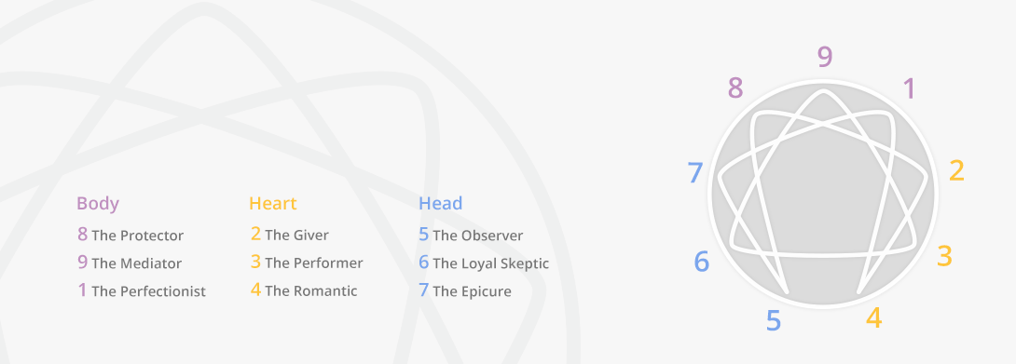

As the name describes, those in the Gut triad (Enneagram types 8, 9, and 1) react and process through life and decisions with their gut or intuition. If you experience the “gut feeling” you may be in this triad. The Gut’s first reaction is to do, and the desire is to have justice or control. There is often a sense within the gut that something is wrong that needs to be made right. That will be magnified in the midst of a crisis. With the current Covid-19 crisis, those in the Gut triad will be the doers who are taking action against any injustices seen. The emotional struggle of this triad is anger. Each Type in this triad has a different way of expressing anger and responding to the injustices they are experiencing.

Type 8 - The Challenger

Type 8s express their anger outwardly. It is an instinctual part of them and can be felt in their intensity and passion. During these uncertain times, their desire to protect themselves and those they love will surface and lead them toward action. They may find themselves during this Covid-19 crisis feeling controlled or manipulated with all of the restrictions that have been put in place. For some, this may be seen in protesting against the restrictions or refusing to follow orders to wear a mask or stay at home, while others are focused and determined to have power over this unseen enemy, the virus, they cannot control. They focus their energy on the things they can control like their own work or protecting their family. Eights will use their gut instinct to provide strong leadership in crisis, naturally making quick decisions and seeking to protect those they love and lead. It is important for 8s to recognize their intensity and attempt to temper it so others don’t feel personally attacked. As an 8, ask the Holy Spirit to guide you as you react and find appropriate avenues to vent the frustrations you may be experiencing. If you are in relationship with a Type 8, be willing to speak honestly and directly to them. They will appreciate clear boundaries and straightforward communication.

Type 9 – The Mediator

Type 9s suppress their anger. They typically do not see themselves as angry people and often present themselves as very easygoing individuals. They want to avoid conflict at all costs. Over time, as they suppress their anger to keep harmony in relationships, it collects in an internal reservoir until it explodes like a volcano. Often their expression of anger does not seem to match the circumstances because it is about so much more than that present situation. During the Covid-19 crisis, we may see the 9s initially approach circumstances with optimism, stuffing any negative emotions that might lead to anger. As they begin to feel and consider the possibilities this pandemic could lead to as time goes on, the anger inside of them may begin to bubble up and spill out. In an attempt to cope and keep inner peace, 9s will often disengage or numb out.

Nines often don’t use their voice to speak their opinions. Their gut reaction may be hard for them to communicate, and they can come across like they don’t care. They need an environment where they are encouraged to express their opinions and preferences or they will often fly under the radar feeling what they have to offer is not valued. As a 9, ask the Holy Spirit to help you process clearly and lead you toward the action you may be trying to avoid. During the Covid-19 crisis, 9s are great at bringing people together, understanding how each person is processing this “new normal.” Their optimistic outlook will be a valuable part of the process of creating a plan moving forward. If you are in relationship with a 9, be patient with them and understand they may withdraw and need time alone to process or escape reality in order to move forward.

Type 1 – The Reformer

Type 1s repress their anger. They see their anger as wrong, so they hold it inside. During the Covid-19 crisis, their anger, that begins as internal frustration, begins to seep out as bitterness and resentment. They experience frustration over seeing people not follow the guidelines that have been issued relating to the crisis. They also become resentful of those that are hoarding resources. Their desire for justice is strongly displayed as they “police” those around them in accordance with the rules. Often, their anger is passive aggressive because they don’t want to be seen as bad or evil.

Type 1s value integrity, health and safety. They have incredible discernment about what is right and wrong. The real strength of the 1 lies in their ability to improve things. They instinctively evaluate everything and immediately spot mistakes or areas of improvement. As a 1, ask the Holy Spirit to help you express your thoughts in a constructive rather than a demanding, critical way. Remember, God is Sovereign, and you don’t have to control the actions of everyone around you. During the Covid-19 crisis, 1s will excel at developing systems and processes within their work or home environments that keep everyone safe. If you are in a relationship with a 1, give them a place to verbally process the frustration that is building up inside of them. See the value in their ability to identify ways to improve the current circumstances.

Stay tuned for Part 2: The Pandemic and the Ennegram – Feeling All the Feelings

